|  |  |  |
| --- | --- | --- |
|  |  | **School Newsletter 26th February 2024 2023** |
| **Ltyentye Apurte Catholic School**  Church Street, Santa Teresa, PMB 221, Via Alice Springs, NT, 0872.  Telephone: (08) 8956 0937 email: robert.dreise@nt.catholic.edu.au |

Dear Families,

**Let us pray that during the season of lent we embrace the opportunity to:**  
  
Fast from hurting words and say kind words.  
Fast from sadness and be filled with gratitude.  
Fast from anger and be filled with patience.  
Fast from pessimism and be filled with hope.  
Fast from worries and have trust in God.  
Fast from bitterness and fill our hearts with joy.  
Fast from selfishness and be compassionate to others.  
Fast from grudges and be reconciled.  
Fast from words and be silent so we can listen.

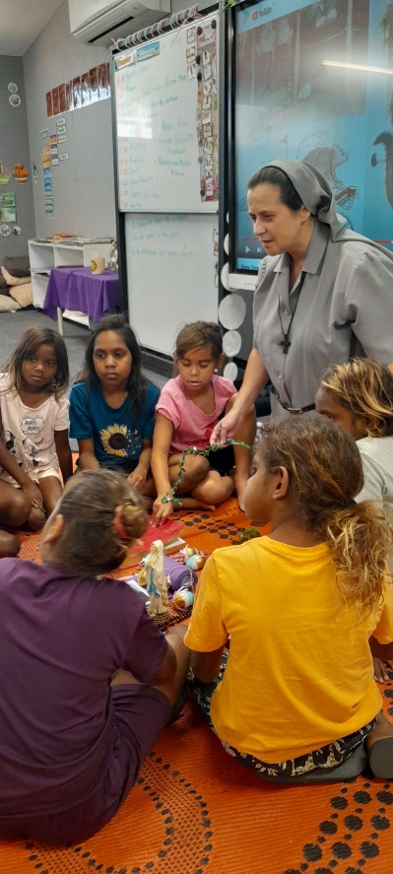

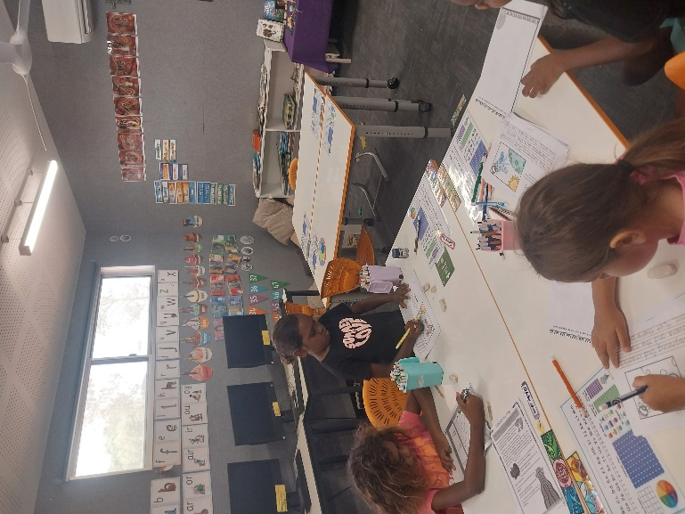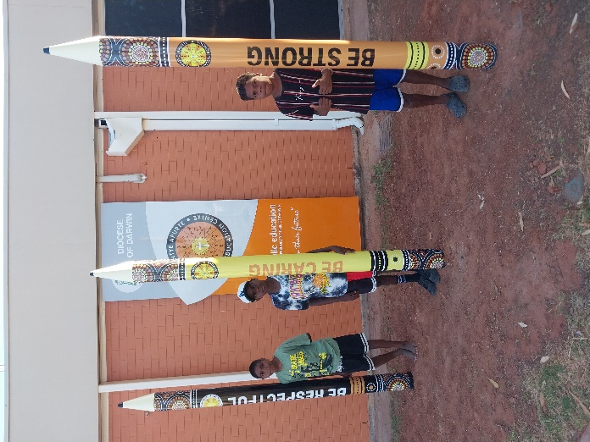

**Grounds and Maintenance**

Thanks to the grounds care team for installing our 3 giant pencils which display our school values of Being Strong, Being Caring and Being Respectful. We encourage our students to live by these values in everything they do at Ltyentye Apurte Catholic School.

**Godly Play**

Recently, Sister Nuria visited classes to present the Gospel through story, wonder, and play. The students thoroughly enjoyed her Godly Play sessions.

**Ltyentye Apurte Catholic School is A Place of Learning**

Students have settled into the 2024 academic year and are working well. Congratulations to teachers and assistant teachers for the excellent work they are doing with their students.

**Other News**

|  |  |
| --- | --- |
|  | **Staffing**  Toward the end of the week, our two new teachers Alex Batty and David Solomon will relocate to Santa Teresa to settle in and prepare to take up their teaching duties next week. Both teachers are very experienced and come highly recommended. We are fortunate to have Helen Currie remain with us for this term. Helen has been invaluable in supporting our school and we thank her for her hard work and dedication. |
| [This Photo](https://fdroog.wordpress.com/category/socialemedia) by Unknown Author is licensed under [CC BY-SA-NC](https://creativecommons.org/licenses/by-nc-sa/3.0/) | **Information Technology (IT): Computer Lab**  Technicians have completed an upgrade of our information technology and upgraded our Wi-Fi. Students will now be able to access the computer lab which will greatly enhance student engagement. Teachers will be able to use the smart board to teach students life-long skills such as creating a power point / slide presentation, word processing, emails, etc. Students will have more opportunities to access technology in the library. As well as the existing desktops, a hub with 8 chrome books will be established as well as a hub with 8 iPads. |
|  | **A reminder that our school is closed before 7:45am. Breakfast will be served at 8:00am**. |
|  | Swimming lessons have started. Please make sure parents / carers have **completed a permission form and returned it to school**. Lessons will be Wednesday, Thursday or Friday so please check that students have a towel and dry clothes to wear. |
|  | **Tommy from AFL NT has started the Aus Kick Program at LACS every Tuesday.**  830am-9am: J1 (On school Lawn)  9am-930: J 2 (On Oval)  930am- 10am: J3 (On Oval)  10am- 1045am: S1 and S2 – Mini Matches on the oval  12-1230: J4 (On Oval)  1230- 1: M1 (On Oval)  1-130pm:  M1, S1, S2 Mini Matches  . |
| Community Members are invited to our upcoming Holy Week Passion Play. Details to follow. | [This Photo](https://religious.najith.com/during-this-holy-week/) by Unknown Author is licensed under [CC BY](https://creativecommons.org/licenses/by/3.0/) |



Have a lovely week,

Mr. D

A/ - Principal